Baltimore Shambhala Meditation Center
Governing Council
Minutes
August 18, 2014
7:00 PM to 9:00 PM
I. Approval of July Minutes
The Governing Council approved the July Minutes.
II. Director of Societal Health and Well-Being
A. Ed, who currently is six months beyond his three-year term as Director of Societal Health and Well-Being, has been working with Tom Burkhart to succeed him. Around the beginning of November, Chris will send a letter of recommendation for Tom to Mary Whetsel, the International Director of Societal Health and Well-Being.
B. After the transition, we need to engage Ed in his next position
1. He can't be Membership Coordinator because the ethics of being a Circuit Court Judge prevent him from asking people for money, even indirectly.
2. Volunteer Coordinator is a possibility. He would need to make a formal request to the Ethics Panel. Ed also would be useful and effective in developing partnerships between the Shambhala Center and other organizations.
III. Implementation of Initiatives?
A. We need a process to ensure execution of Plenary Meeting and Governing Council decisions.
B. A team of project facilitators could be charged with assisting committee chairs and other leaders in executing this decisions
1. Project facilitators would assist committee chairs and other leaders in using project management discipline to
a) Plan project execution
b) Identify and assign tasks
c) Monitor task completion
d) Evaluate project execution progress
e) Revise project plans, as necessary
2. The project facilitators would work with the various committee chairs and their committees to guide project completion.
3. We still are very much in need of a Membership Coordinator and Volunteer Coordinator.
IV. Harvest of Peace
A. Lisa has submitted a plan for Harvest of Peace
B. The Center of the Mandala envisions Harvest of Peace for the launch of Unified Giving, Phase II.
V. Finance
A. The Council decided to engage a payroll service such as ADP or PayChex to process our payroll.
1. The service will carry out all tax filings and be legally responsible for any penalties that would occur from unfiled or improperly filed 940s, 941s, and W2s.
2. In addition to penalties for non-filing in prior years, we now have been penalized for non-filing in 2013 and 2014.
3. Our current systems for filing 940s and 941s through Intuit and QuickBooks are not working, and we don't know why.
B. E. Martin Davidoff & Associates
1. With Greg Caruso's help we have engaged, on a pro bono basis, this firm, which specializes in tax controversy matters.
2. www.taxattorneycpa.com
3. They now are working with the IRS to find out why they are not receiving our tax documents and to seek mitigation of the penalties.
C. Ray has recommended that we engage an outside CPA firm to manage our finances.
1. Despite the fact that we have had people with good professional credentials involved as Treasurer, e.g., CPAs, financial responsibilities have overly challenged and frustrated our Treasurers and Chadgzus.
2. In the past, leadership issues have undermined our financial systems.
3. Financial systems, such as they are, risk unraveling during transitions in leadership or finance. New financial leadership reestablishes systems according to their own understanding or preferences. Consequently, continuity of operations is lost, and it is not possible to understand what occurred financially under prior regimes.
4. C.E.A. Scholtes & Associates
a) www.ScholtesCPA.com
b) Ray and Chris met with Chris Scholtes, a CPA firm specializing in small to mid-sized non-profits, who offered to help us by managing the Organization’s general ledger including –
(1) Recording receipts from deposits made by the Organization.
(2) Using online banking/bill pay functions pay all invoices approved by the Treasurer or someone else appointed in the Organization’s leadership.
(3) Prepare monthly financial statements including a balance sheet and income statement.
(4) Evaluate current internal controls and pose suggestions for strengthening internal controls in a practical way.
(5) Provide suggestions for hiring a third-party payroll provider, record all payroll transactions (we note 2 employees currently).
5. Cost-- Based on 15 checks per month, 60 receipts, 2 PT employees paid twice a month, 1 debit card soon to be credit card – guessing under 10 transactions per month, monthly board reporting, 1 checking account to reconcile each month, 1 credit card to reconcile we’re estimating 4-6 hours per month which would translate into about $400 to $575 per month.
6. Decision: Explore the possibility of C.E.A. Scholtes & Associates performing an audit before our committing to engaging them in our monthly transactions.
D. Ray has prepared a six month financial report.
One of the financial goals for 2014 was to demonstrate our financial sustainability by experiencing six (6) consecutive months of positive cash flow and maintaining a minimum of $50,000 in cash reserves. Unfortunately, we have not been able to realize this goal to date. For the six month period, BSMC has experienced a net loss of $7,366 on income of $67,768. (For the same period in CY. 2013, BSMC experienced a net gain of $11, 398 on income of $81,797). Two factors have contributed most significantly to the shortfall in net income for this period:
1. An unanticipated IRS penalty for failure to file payroll tax reports from calendar years 2005 and 2007, During this period, an IRS lien was placed on our bank account. Upon investigation, we discovered a liability for penalties resulting from unfiled payroll tax Form 941 for cal. years 2005 and 2007. To date, we have paid out $8,622 to the IRS to remove the lien and satisfy the penalties accrued. In July, we received another letter from the IRS citing our failure to file quarterly and year end reports (Forms 940 and 941) for 2010, 2011, 2012, 2013 and quarterly reports in 2013 and 2014. Penalties amount to an additional $4,480. The IRS subsequently agreed to withhold collection of the $4,480 while we prepare and send the appropriate filings. Upon receipt and review, the IRS has agreed to reassess our penalty.
2. Income from membership contributions and other donations has been below budgeted expectations. While program income has remained at or above budgeted levels for 2014 (revenue from programs for the six months of 2014 is $32, 898 compared to program revenue for the same period in 2013 of $31, 068), income from membership contributions and donations has been and continues to be below expectations. For the six months of 2014, membership contributions were $18, 455 and other donations amounted to $13,071for a total of $31, 526. For the same period in 2013, membership contributions were $28,463 and other donations were $16, 816 for a total of $45, 279. The difference represents a shortfall $13, 753 for the six months ending June 2014.

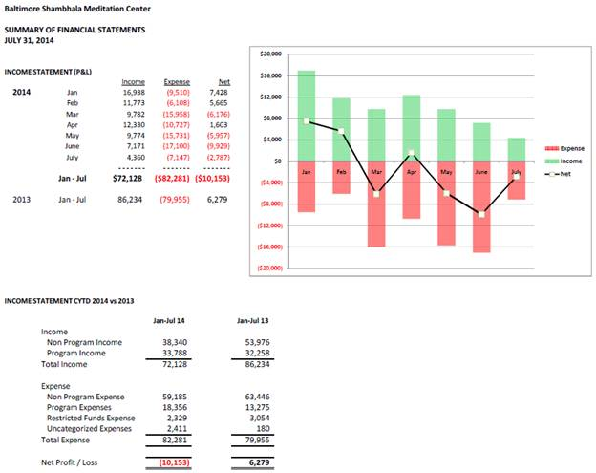

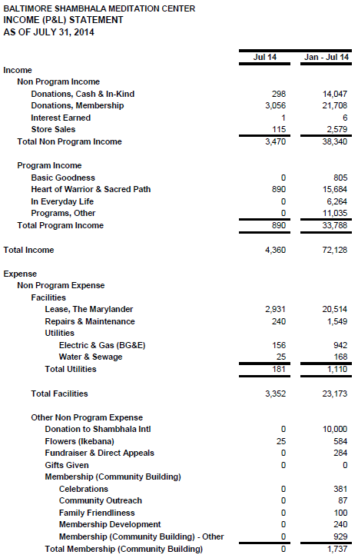
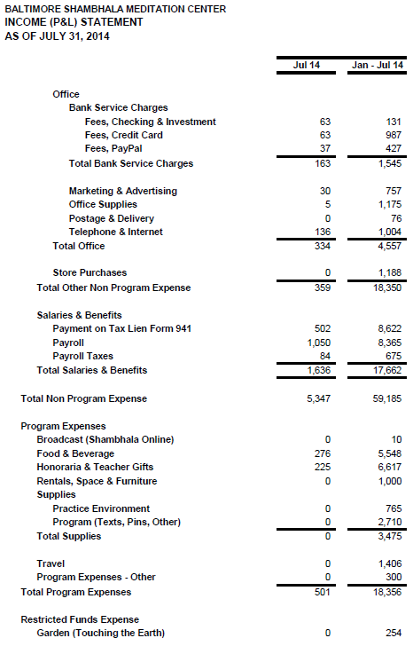
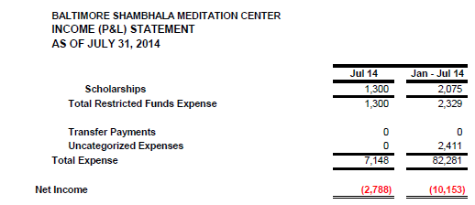

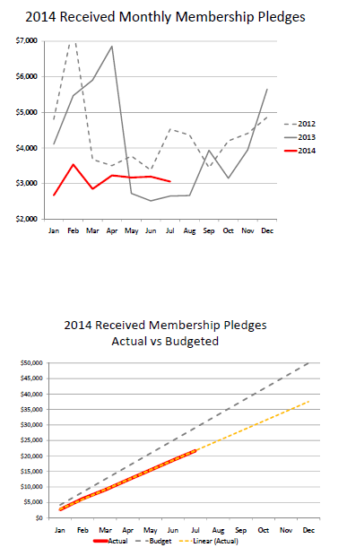

E. Scholarship Policy—Ray has drafted a scholarship policy for approval.

