Baltimore Shambhala Center
Governing Council
Minutes
June 9, 2014
7 PM to 9 PM

Members Present: Susana Arriagada, Ed Hargadon, Chris Kreeger, John Lamoureux, Eric Laufe,
Raymond Robinson, Lisa Wenrich

Ø Approval of May Minutes
The Minutes of the May 12, 2014 Governing Council Meeting were approved, with one spelling correction.

Ø Financial Report
§ May Financial Results
§ Our Treasurer reports that, for May 2014, our Center had a net loss of $6,592 on $9,139 income (-72%). (See Attachments). This loss was largely due to a $5,290 payment on an IRS lien filed against our Center for failure to submit payroll tax form 941s for the years 2005 and 2007. It is noteworthy that without this payment, our Center would still have experienced a net operating loss for the month. For the calendar year-to-date, our Center has earned $60,387 against $58,350 for a net gain of $2,037 (+3.4%).

§ By comparison, last year (Jan - May 2013) saw a net gain of $14,155 on $74,433 income (+19%). On the positive side, program income is slightly higher (+$2,000) in 2014 versus 2013, and non-program expenses were significantly lower (-$9,666; salary savings). Non-program income, however, is significantly lower this year (-$16,000); received membership pledges, for example, are $10,000 lower for 2014 ($15,057) than 2013 ($25,073). Also of concern is the lower ratio of program income versus cost this year (1.85) compared with last year (2.80).

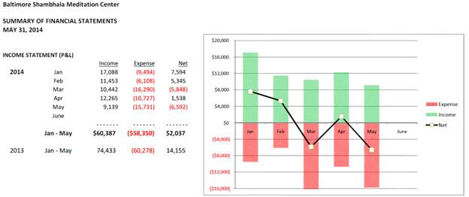
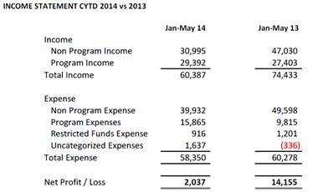

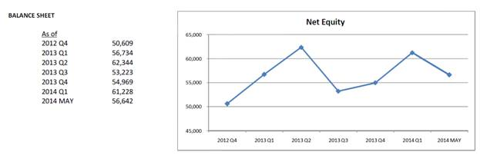

§ Caution is advised to mindfully hold down Center expenses as we enter the summer months with its small number of scheduled programs, compounded by a reduced "cushion" ($2,037 versus 2013's $14,155) earned during the five months to date.
§ Internal Reporting
· In the past, the Center has experienced difficulties complying with Federal and State requirements, and so in the past year we have had to pay penalties for our failure to submit Maryland Property Tax forms and 941s in prior years. Our current Treasurer is diligent in complying with these issues. At the same time, it is the Governing Council’s ultimate responsibility to make sure that systems are in place to comply with these requirements. Governing Council and Treasurer incumbents change, and without appropriate internal reporting systems compliance might change with the change in the incumbents. John, Ray, and Chris will work together to set up these systems.

· Credit Card
· The Council approved Ray obtaining a credit card account for the Center.

Ø Carpeting
§ Lisa has been attempting to arrange the installation of new carpeting, but neither the Marylander Property Manager nor the carpeting contractor has responded to her emails and telephone calls. Chris and Lisa will set up a meeting with the Marylander Property Manager.
§ We have a $6,000 carpet allowance due to us from the Marylander. This amount will enable us to re-carpet the Living Room, the Teacher's Room, the Business Office, and the Stairs. We will wait on the Shrine Room, Classroom, and Bodhi School Room until we've got sufficient funding to pay for those. Given our looming deficit situation for the year, it would not be prudent to dip into reserves to purchase more carpeting.
§ Greg Caruso is poised to launch a Fundraising Campaign to augment the amount of carpeting we can replace at this time. Lisa will work with Greg to frame the appeal, indicating that we will be able to replace more carpeting in the Shrine Room, Classroom, and Bodhi School to the extent that we can raise the money to pay for it.

Ø Administrative Issues
§ At its May meeting, the Governing Council made the following observations:
During the 10 years the Center had a paid director, perhaps 80% of that person's time was spent on administration, with a smaller percentage devoted to leadership. Times have changed. We now have a volunteer director for the foreseeable future. More importantly, the Sakyong and the Center of the Mandala are urging Center Directors to devote the vast majority of their time to leadership, with the Executive Committee providing for administration. Again, Executive Committee members and our Chief Of Staff, John Lamoureux are volunteer positions.
In the past, when our paid administrative support staff were providing support to paid administrators (i.e., the Center Director), the Center Director was able to provide administrative structure. He or she supervised the administrative support staff and ensured that administrative tasks were accomplished. The Council discussed the need to improve efficiency in the office. The Council asked John to look at the methods discussed, and to discuss the issues and suggestions with the staff.
§ Given this shift in our governing and administrative structure, the Council decided that the Center ultimately will need a paid Center Manager, similar to the position other Centers have had. Chris will discuss the role of the Center Manager with the Center Director for Austin, since they have worked with this position, and possibly get a job description from her. In addition, the Council decided to establish a task force involving Council members and others to explore what the duties and qualifications of a Center Manager would be. The Center's current financial situation would not permit us to hire someone for this position, but that would change if we can fix our dues situation.

Ø Membership
§ At the May Governing Council Meeting, Ray pointed out that we keep having discussions about membership without nailing down a system for recruiting and engaging new members, securing their dues payments and volunteer commitments. He suggested that we need a business process map that displays the whole process. The map would show where there are gaps that we then need to address. Chris met with Janet and Paul to discuss the processes that they have initiated and then produce that map.
§ Chris produced the map and shared it by email with Janet, Paul, Kate, John, and the office staff, asking that they review it and verify that it accurately reflects their responsibilities. As of this moment, there are at least two, recent instances where our system failed to establish people as members who registered as members on the website.
§ In today’s meeting, John suggested three additions to the flowchart:
· The Office Staff should look in junk email for new member messages from the system, since Claudia has been finding these in junk mail.
· The Treasurer should be informed of new members.
· The Treasurer should verify in the Shambhala Database that the person is not already a current member.

Ø Implementation Protocol
§ The Governing Council, Executive Committee, and other leadership make decisions, which then must be implemented by others. The others generally are volunteers who have a lot of other things to do. Consequently, there are multiple opportunities for implementation failure. Those who we feel are best positioned to carry out required tasks might be unable or unwilling to do them. The tasks might not be defined well enough, so that people are unclear about what they are being asked to do. The sequence of tasks might not have been well enough thought through, so that unanticipated obstacles arise.
§ When a decision is made, that decision should be followed by a project plan to guide and monitor its implementation.
§ Following this process will guide projects through to their implementation and also clarify obstacles which impede implementation. People will be able to be accountable in a way that they are not able now. By clearly defining and sequencing tasks, it will be possible to break projects up into smaller parts, so that more people can be engaged by carrying out limited tasks.

Ø Monthly Newsletter
§ Samantha Solomon, who had agreed to lead our newsletter effort, has indicated that she cannot do so right now because she must complete her Master’s thesis between now and the fall. She would be available to lead the effort this coming winter.
§ At this point, the plan is to postpone the newsletter until winter time, when Sam can lead the effort.

Ø Plenary Meeting
§ The Summary of the Plenary Meeting, which took place May 31, 2014, reflects leadership’s suggestions for improvement in marketing, newcomer engagement, finance, capacity development, and membership engagement.
§ Implementation experience over the past three months indicates that the Center Director or his or her designee must ensure there is a proper team and structure for engaging in the project. Those projects that already had that team and structure in place did better than those that didn’t.
§ The Center Director will work with the Plenary Meeting results further to establish specific, workable projects and to recruit the right team to conduct those projects.

